**Internship Report on**

**ORGANISATION STUDY AT GILWOOD FASHIONS PVT LTD**

Submitted by

**RUCHITHA HM**

**4MH23BA135**

Submitted to

**VISVESVARAYA TECHNOLOGICAL UNIVERSITY, BELAGAVI**



In partial fulfilment of the requirements for the award of the degree of

**MASTER OF BUSINESS ADMINISTRATION**

**(SUBJECT CODE:20MBAIN307)**

**Under the guidance of ,**

**INTERNAL GUIDE EXTERNAL GUIDE**

**Prof. suheel Mr. Rajesh**

Assistant professor Destination: HR Manager

Department of Managementscience Gilwood fashions pvt. ltd

Maharaja Institution of Technology Mysore



MAHARAJA INSTITUTE OF TECHNOLOGY MYSORE

**(**Affiliated to VTU, approved by AICTE, New Delhi & Recognized by Govt. of Karnataka)

Department of Management Sciences

BACH NO: 2023-2025

**DECLARATION**

I, RUCHITHA HM ,4MH23BA135 hereby declare that the Internship report with reference to **Gilwood fashions pvt ltd somanahalli,** prepared by me under the guidance of **Assistant prof. PROF.SUHEEL** , MBA Department **Maharaja institution of Technology Mysore** and external assistance by **Rajesh HR Manager**. I also declare that this Internship report is towards the partial fulfillment of the university Regulations for the award of degree of Master of Business Administration by Vishveshvaraya Technological University, Belagavi. I have undergone a internship for a period of four weeks.

I further declare that this Internship is based on the original study undertaken by me and has not been submitted for the award of any degree/diploma from any other University / Institution.

Place: Mysore Signature of the Student

Date: RUCHITHA HM

**ACKNOWLEDGEMENT**

It was my privilege to do Internship study at **Gil wood fashions Pvt Ltd.** There are many people who have helped me to complete this study successfully. It is with the gratitude that I acknowledge the help, which guided my efforts with success.

I wish to express my profound gratitude to the management and administrative team of **MITM** for their constant encouragement.

I express my sincere thanks **Dr Naresh kumar B G** **Principal, MITM**, for his kind words of motivation and facilitating me in an organization for internship.

I also express my sincere thanks to **Head of Department, Dr. Pushpalatha V Department of MBA** for being the backbone of support throughout the study.

It is my foremost duty to express my wholehearted thanks to my guide **Assistant Prof. Suheel** for the valuable guidance, support and motivation during the course of this study. The inspiration provided by my guide at every stage of my work has helped me immensely in completion of this internship study and preparation of this report.

Last, but not the least, I am indebted to my family members and friends for their blessings and encouragement.

Place: MYSORE Student Name:

Date: RUCHITHA HM

4MH23BA135

**CHAPTER-1   
 INTRODUCTION ABOUT THE INDUSTRY AND ORGANIZATION**



Fig no.1.1

The garments industry also known as clothing or apparel industry is a popular and dynamic sector that encompasses the design, manufacturing, and distribution of clothing and textiles. This industry plays an important role in the global economy, and contributing to both fashion trends and consumer needs.

Gilwood Fashions Private limited is an private company incorporated on 19 August 2009. It is classified as a private limited company and its HeadQuater in Bangalore, Karnataka. It’s authorized share capital is INR 10.00 lakh and the total paid-up capital is INR 1.86 lakh. the company is engaged in manufacturing of garments for Mens. It has a history of 13 years. A prominent company which are engaged in providing quality services by manufacturing the quality products.

The domestic apparel & textile industry in India contributes approx.. 2.3% to the country’s GDP, 13% to industrial production and 12% to exports. India has a 4% share of the global trade in textile and apparel. India is one of the largest producers of cotton and raw material in the world.

**INDIAN VIEW**

The garments industry of India is an Rs –one trillion industry. Almost 33% of it’s knitwear production and about 20% of it’s woven-garment production, both by volume, enters export markets. Overall about 25% of the volume of it’s garment production goes into export markets, leaving 75% for domestic consumption.

Industry covers over one lakh units and employs about 6 million workers, both directly indirectly in almost equal proportion. The indirect portion helps to sustain the direct production sector in the shape of items associated with the garments industry production including sewing thread, buttons, zippers, T-shirts, shirts, pants, jackets and packing material.

Organized sector of the garments is roughly 20% of the total industry, concentrating chiefly on exports. These are usually limited companies while the rest are proprietary companies. Geographically, men’s garments predominates in western and southern India while production of ladies garments predominates in north India. Eastern section of India specialize in children garment where in fact, these look their birth. Fabric-wise, 80% of the production is of cotton garments, mixed garments and the rest of silk and wool garments.

**WORLD VIEW**

The global pandemic of 2020 has highlighted the geographically dispersed, yet connected nature of many business activities as well as levels of inequality within and between countries. The Covid-19 crisis caused some clothes retailers in developed economies to cancel orders with their suppliers, exacerbating yet further the living conditions for many workers in the garment industry in Bangladesh (Deutsche Welle, 2020; Kelly and Ahmed, 2020; Reinecke and Donaghey, 2015). Indeed, for many years, production in the garment industry has shifted from one location to another (Gereffi, 1994); each move drives the economy, but simultaneously damages the environment and creates inequality.

The international trade in the sixteenth century by colonial multinational corporations (MNCs), such as the East India Company, which is a forerun- ner of modern MNCs, drove the creation of early value chains in the textile industry between Europe and Asia. These affected not only the condition of textile and cotton manufacturers in India, but also the garment manufacturers and consumers in England (Gupta, 2013).

A geographical spread of economic activities across national, particularly colonial, boundaries with low-value creation at the supply side and low levels of functional integration characterized the internationalization processes in the global production network of textile and clothing industry between India and Europe (that is, as a large clothing market in the seventeenth century). Although this was the beginning of internationalization and the creation of a global production chain, studies in international business have largely overlooked this phenomenon, and not only that, they have also ignored the examination of the internationalization phenomenon within the global value chain network of the global textile and garment industry.

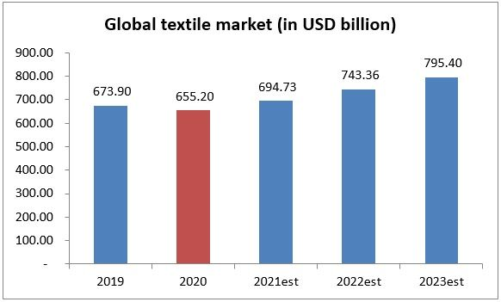

**CHALLENGES**

* **Shortage in supply of raw materials:** because of pollution issues some unit of china and Europe has been shut down due to which rise in the prices of basic raw material has resulted and there are many other factors like weather etc which are influencing the raw material supply.
* **Increase in cost of raw material:** unpredictable market condition, weather, policies etc have resulted in an increase in raw material costs.
* **Heavy noise pollution and rising environmental concerns:** The textile industry is a noisy one-there are no two ways about that. Dally operations, like machine gearing, air compression, draw from functioning and licker speeds, generate high amounts of unwanted (and often, loud) sounds. This is a serious point of concern for everyone working in textile mills – specifically when the sound pollution goes beyond the 100 DB mark. Going forward, due attention needs bring down the noise levels generated everday at textile manufacturing units.
* **Environmental problems:** environmental compliance often isn’t at the top of textile and garments importers concerns.
* **Fragmentation and skill shortage are affecting the textile industry:** while the average size of textile units (say, weaving units) in India is smaller than those in the US and china, the bigger problem is the acute fragmentation. Only around 5% of the apparel industry can come under the ‘organised’ classification-hurting the probability of the fabric manufacturers.

**FUTURE DEVELOPMENTS IN TEXTILE (GARMENTS) INDUSTRY**

By 2025, the textile sector in India is anticipated to attract investments totaling US$120 billion and grow exports to US$ 300 billion.

* **Sustainable Fashion:** Further advancements in eco-friendly materials and production methods to reduce the environmental impact of clothing production.
* **Smart Textiles:** Integration of technology into fabrics, enabling functionalities like temperature regulation, biometric monitoring, and even interactive clothing.
* **Customization and Personalization:** Enhanced use of AI and technology to offer more personalized and tailor-made clothing to consumers.
* **Robotics in manufacturing:** Further integration of robotics and automation in the production process for increased efficiency and precision.
* **Block chain for Transparency:** Increased use of block chain to ensure transparency and traceability in the supply chain, ensuring ethical and sustainable practices.
* **3d printing in fashion:** Increasing use of 3D printing for creating clothing, which allows for efficient, customized, and waste-reducing production.
* **Circular fashion economy:** Implementation of circular fashion models, emphasizing recycling, upcycling, and reusing materials to minimize waste.

**CHAPTER-2**

**ORGANIZATION PROFILE**

**1.BACKGROUND ON THE COMPANY**

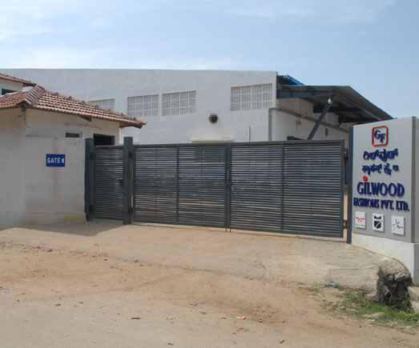

Fig no 2.1

From its modest beginning in 2009, with just one production unit, Gilwood Fashions Private. Limited (GFPL) has now evolved into Rs. 40 crores group manufacturing apparels- an upcoming own brands for India market in young Men’s & boy’s shirts, pants, and jackets. An aggressive phase of expansion during the last 5 years has brought us to where we are today-India’s known domestic apparel brands with two production facilities in Bangalore and one at Maddur in Mandya district of Karnataka. Always GFPL remains committed to provide quality products and services to all customers at all times.

GFPL are one of fastest growing garments company of us$ 20 million. We are a fast growing garments manufacturer from India, providing an entire garments services from sourcing to garmenting.

GFPL can offer the leading brands the world the best of services, right from design interpretation to fabric, garmenting facilities and efficient logistics. GFPL are an integrated company that has in-house embroidery, printing and garmenting facilities backed by state of the art machineries and quality assurance systems.

It was founded march 2012 in maddur, Karnataka, somanahalli industrial area. More than 800 employees.

Present chairman & managing director:- Manish Dugar.

**2. NATURE OF BUSINES**

The Gilwood fashions private limited total built area 555500sq.ft. include machines like: automatic cutting, fusing. High tech stitching, inter locking, button stitching. Production capacity 12,00,000pcs per annum.

* Pattern & sampling supports by rich peace CAD.
* Centarlised fabric store & cutting room equipped with IMA spreaders, HASHIMA fusing & Eastman band knife.
* Sewing hall is in to 2 separate section A for shirts & sweat shirts and section B for bottoms & jackets each stitching lines, both sections are supported with separate finishing & packing areas.
* Both the stitching sections are set the art computerized stitching machines.
* Automation is a continuous innovation, constantly evaluated for cost effectiveness and implemented by experts in upgrading industrial engineering concepts to improve efficiency.

**3. VISION MISSION, QUALITY POLICY**

**VISION**

Be the global best in bringing delight to human weaving dreams of fashions and feelings of comfort.

**MISSION**

* Gilwood fashions private limited is committed to the consistent up liftment and improvement of both its products and its responsibilities towards its employees.
* Striving hard
* Striving hard to achieve highest levels of customer satisfaction through timely deliveries along with enhanced, quality and value of all products.

**QUALITY POLICY OF GILWOOD FASHIONS PRIVATE LIMITED.**

* Pattern – sampling cutting
* State of the art CAD room equipped with latest
* RICHPEACE software to provide precision patterns & makers consistently
* Well-equipped sampling room with experienced tailors
* Cutting room equipped with IMA – auto spreaders 2 numbers
* With 2*16 mtr tables, HASHIMA fusing, Eastman straight
* Knife & band knife cutting machines
* Line inspection to address issues related to laying, spreading, cutting
* From cut of pack standard quality control systems are implemented by well-trained QC team. Our product speaks by itself of the best practices followed meticulously to the satisfaction of the customer.
* When the process matters, it always shows in the results. Our meticulous attention to every minute detail begins with the cutting and extends into the stitching, washing and packing stage of the process.
* Technical training is imparted to operators before start of working.

**4. WORK FLOW MODULE**

|  |
| --- |
| Fabrics |

|  |
| --- |
| Cutting |

|  |
| --- |
| Sewing |

|  |
| --- |
| Button Holing & Buttoning |

|  |
| --- |
| Trimming & checking |

|  |
| --- |
| Ironing & Finishing |

|  |
| --- |
| Packing |

|  |
| --- |
| Dispatch |

**Fabrics:** 4-points system for inspection by professional trained manpower. In house lab for testing various fabrics parameters like shrinking, spirality, wet and dry rub, color fastness to washing etc.

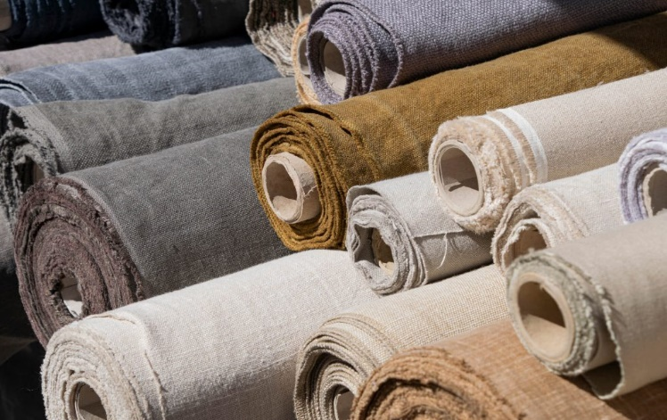

Fig no 2.2

**Cutting :** state of the cutting room equipped with latest CAD to provide precision cutting consistently. Fabrics is relaxed to control shrinkage. In majority of cases panel wash is done to arrest shrinkage, and spirality. Online inspection to address issues to laying, spreading, cutting.

**Sewing:** stress on the process standardization to enhance quality and productivity desking operation by using folders guides patterns to get quality. SPE concept minimum WIP in the lines there by making it easier to control quality. In line the inspection points to weed out issues as possible to the needle. An independent audit team audits pcs after end line inspections.

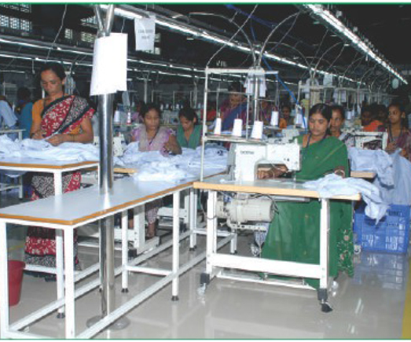

Fig no 2.3

**Button Holing & Buttoning:** Button holing is a reinforced hole that a button can pass through allowing one piece of fabric to be secured to another. The raw edges of a button hole are usually finished with stitching. This is also done through proper expertise employees.

**Trimming & Checking:** Assure trims are used in bulk production are in the acceptable quality level and minimize garments rejection due to trim defects. Trims inspections are much important for any garments manufacturing industries. It enhances the visual appearance and functionality of a clothing item. Checking is the testing all what is used in making the garments.

**Ironing and Finishing:** A strong and independent team to certify the quality before final shipment. Quality and social accountability are the basic business strategy of Gilwood fashions for stability growth and leadership and also ensure the proper ironing of materials before the products dispatches.

**Packing:** The employees are engaging in the process to keep the product safe and secure from external environment. They took care of each and every element while packing the product. They aim to deliver a good product which satisfies the needs of both customers and dealers.

**Dispatch:** The employees is dispatch department is to check the availability of input materials and ensure the movement of material from store to first process and then from process to process and to ensure the availability of all production and inspection aids.

**5. PRODUCTS AND SERVICES PROFILE**



Fig no 2.4

**The major products are:**

* Men’s Shirts
* Pants
* Shorts
* Jackets
* Sweat Shirts

**The major services are:**

* Development in textile apparel
* Knowledge sharing
* Textile garments designing
* Environmental protection
* Employee welfare measures
* Medical centers with proper equipment
* Good transport facilities for employees
* Testing and research and development equipment
* Quality product and services at affordable price.

**6. OWNERSHIP PATTREN**

|  |  |
| --- | --- |
| **DESIGNATION** | **NAME** |
| Managing director | Manish Dugar |
| Factoring manager | Bhupendra manager |
| Area sales manager | Venkata cantyada |
| Senior mechanical technician | Ashok lokappa |
| H R manager | Rajesh |
| Senior account analyst | Ronak surana |
| Merchandiser | Vidya koppal |
| Sampaling incharge | Anand |
| Factory merchandiser | Vijay kumar |
| CAD manager | Rakesh |
| Account manager | Bhaskar |

* Gilwood fashions private limited has one director:- Manish Dugar.
* The paid-up capital of GFPL is INR 1.85 LACS.
* The authorized share capital of GFPL is INR 10.0 LACS.

**COMPITETOR ANALYSIS**

* Shree Gajanana Silk Mills Private Limited.
* SPA Merchandise Private Limited.
* FAIR price FBRICS Private Limited.
* OMI broderies Private Limited.

**7. FUTURE GROWTH AND PROSPECTS OF THE COMPANY**

In the emerging face to fast moving information, technological transfer is bound to take place at a higher speed.As the international border bulk supply chain management and information technology take a crucial role in apparel manufacturing. Global partners in the clothing supply chain are exchanging information technology, thus need for the indian clothing industry to spruce up.

Upcoming technology for mass customization such as three dimensional non contract body measurement and digital printing ought to be discussed thoroughly and implemented fast. This mass customization shall be successful for meeting unpredictable demand levels for luxury goods, services uncertain customers wants for heterogeneous demand. It is to be noted that mass customization is different from mass production.

Scale and coordination have been the foundation of our methodology to drive edges around here. Has scowl both naturally and inorganically to accomplish its vision. We have obtained a few organizations with a specific end goal to boost the advantages of vertical incorporation and economics of scale.

**CHAPTER-3**

**MCKENSY’S 7S FRAME WORK AND PORTER’S FIVE FORCE MODEL WITH SPECIAL REFERENCE TO ORGANIZATION UNDER STUDY**

**MC KENSY’S 7S FRAMEWORK:**

The McKensy’s 7s model is a strategic tool and framework that helps managers and business assess their performance. The McKensey’s 7s model identifies the 7 key elements for an organization that need to be focused and aligned for successful change management processes as well as for regular performance enhancements.

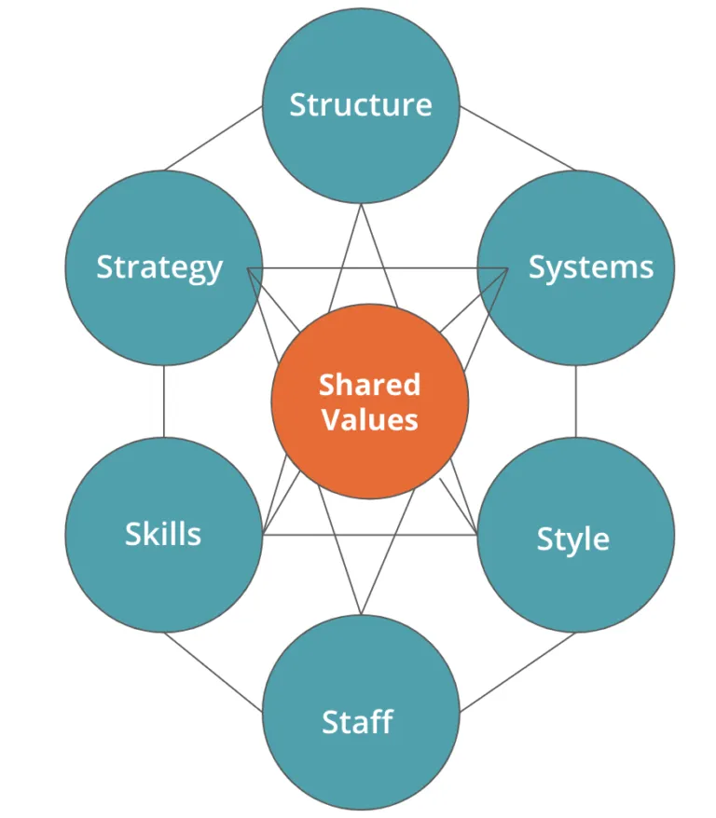

Fig no 3.1

**1.STRATEGY:**

The plan devised to maintain and build competitive advantage over the competition. A strategy refers to a method or plan chosen to bring about a desired future strategy is the direction and scope of an organization over the long term, which achieves advantages in an ever changing environment through its configuration of resources and competencies 3 with the aim of fulfilling stakeholder expectations. Strategy which a fundamental management tool in any organization is a multi-dimensional concept that various authors have defined in different ways. It is the match between an organization procedure and operations to achieve that future and determine how success is to be measured. It ia a systematic process through which an organization argues on and builds on commitment among stakeholders to priorities which are essential to its vision and mission and to be responsive to the ever changing operating environment. GF products and fairly priced and reasonable price for a product or service that is fair to both parties involved in the transaction. This amount is based upon the agreed conditions, promised quality and timeliness of contract performance.

**2. STRUCTURE:**

The company has a flatter Organization structure that is supported by learning and progressive organization. With lesser managerial levels in between and more access to the senior management and leadership, the employees feel more secure and confident and also have higher access to information. Moreover, the flatter also allows quicker decision making process in the company and increases organizational commitment in the employees.

Organization structure used by gilwood fashions pvt ltd businesses have been structured in a hierarchical way with several divisions and departments, each responsible for a specific task. Although this is still the most widely used organizational structure, the recent trend is increasingly towards a flat structure where the work is done in teams of specialists rather than fixed departments. The idea is to make the organization more flexible and devolve the power to employees by eliminating the middle management layers.

|  |
| --- |
| General manager |

|  |
| --- |
| Factory manager |

|  |
| --- |
| SR. Merchandiser |

|  |
| --- |
| CAD Manager |

|  |
| --- |
| Accounts manager |

|  |
| --- |
| HR Manager |

|  |
| --- |
| Assistant merchandiser |

|  |
| --- |
| supervisor |

|  |
| --- |
| Assistant CAD operator |

|  |
| --- |
| Assistant accountant |

|  |
| --- |
| coordinator |

|  |
| --- |
| welfare officer |

|  |
| --- |
| HR executive |

|  |
| --- |
| Nurse |

|  |
| --- |
| Security supervisor |

|  |
| --- |
| Security |

**3. Systems:**

The daily activities and procedures that staff members engage in to get the job done. System refers to the formal and informal procedures used to manage the organization, including management control systems, performance management system and reward systems, planning, budgeting and resource allocation systems and management information systems. Every organization has some systems or internal processes to support and implement the strategy and run day-to-day affairs. These processes are normally strictly followed and are designed to achieve minimum effectiveness. Traditionally, organizations have been following a bureaucratic style process module where most decisions are taken at the higher management level. Increasingly, organizations are simplifying and modernizing their processes by innovation and use of new organizational structure to make the decision making process quicker. Special emphasis is on the customers with the intension to make the processes user friendly.

1. Employee recruitment and selection system.

2. Production process system

3. Training and development system

4. Team development and orientation system,

5. Transaction processing systems,

6. Customer relationship management system.

7. Business intelligence system.

**4. SHARED VALUES:**

Shared values called “ordinal goals” when the was first developed these are the core values of the company thar are evidenced in the culture and the general work ethic. Shared values is the core or fundamental set of values that are widely shared in the organization and serve as guiding principles of what is important: vision, missionvalues statements that provide a broad sense of purpose for all employees. All members of the organization share some common fundamental ideas or guiding concepts around which the business is built. Thus may be to make money or to achieve excellenc**e** in a particular field. These values and common goals keep the employees working towards a common destination as a coherent team and are important to keep the team spirit alive. The organizations with weak values amd common goals often find their employees folloeing their own personal goals that may be different or even in conflict with those of the organization.

**5. STYLE:**

Style refers to the leadership style of managers;hoe they spend their times;what they focus attention on; how they make decision; also the organizational culture, that is, the dominant values and belifs, the norms, the conscious and unconscious acts taken by leaders. All organizations have their own district culture and management style.

GF have traditionally been influenced by the military style of management with strict adherence to the upper management and procedure expected from the lower-rank employees, however, there have been extensive efforts to change the culture to a more open, innovation and friendly environment with fewer hierarchies and smaller chains of command.

**6. STAFF:**

The employees and their general capabilities. Staffs refers to the people, their competencies: how the organization recruits, selects, trains, mamages the coreers, and promotes them. Organizations are made up of humans and it’s the people who make the real difference to the success of the organization in the incresingly knowledge-based society. The importance of human resources has thus got the central position in the strategy of the organization. All leading organizations put extraordinary emphasis on hiring the best staff, providing them with rigorous training and mentoring support, and pushing them to achieve professional excellence. It is also important for the organization to instill confidence among the employees about their future career growth. Skills refers to the distinctive competencies; what it does best along dimensions such as people, management practices, processes, systems and customer relationships.

**7. SKILLS:**

The actual skills and competencies of the employees working for the company. The following are the skills passessed by the employees.

1. Techical skills:- elecrical skills, production skills, electronic skills.
2. Administrative skills:- managerial skills, numerical skills, financial skills.
3. Operational skills:- taking care of machineries, maintenance and its operations, processing and scheduling of raw materials, quality assurance and so.
4. Marketing skills:- distribution of transformer advertisement and promotion, customers and feedback.

**PORTER’S 5 FORCE MODEL**

Porters five analysis is an approach to determining just how competitive a given market is, and consequently, how profitable it may be for a business. This framework draws on five factors.

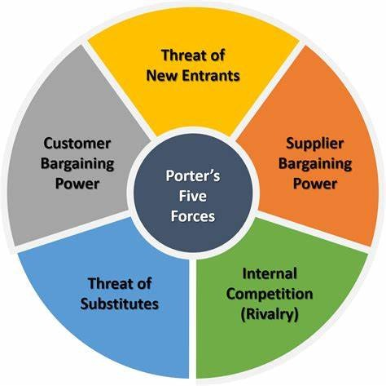

Fig no 3.2

**1.THREAT OF NEW ENTRANTS:**

* Low barriers in the domestic market.
* Economic of scale are high.
* Brand identity of a company in this GF is high.
* Capital requirements to establish a regional or a national level operation are high.
* This GF is not lucrative.
* The companies operating at the national level to manage to make economic profit but entry barrier at this stage are very high.
* Thus the threat of new entrants is moderate.

**2. BARGAINING POWER OF BUYERS:**

* High demand for apparels and home textiles in us and markets.
* Product differences and brand identity are quite high.
* Buyers concentration is very low.
* Buyers volume is general low.
* Buyers information is high.
* Ability to backward integrate is very low.
* Thus the bargaining powers of buyers are low.

**3. BARGAINING POWER SUPPLIERS:**

* High availability of cotton.
* Low cost of labor.
* Differentiation of substitute inputs to cotton like polyester, wool, ilycra ect are present.
* Importance of volume to suppliers is very high.
* Cost relative to total purchase in GF is low.
* Thus bargaining power of suppliers is low.

**4.THREAT OF SUBSTITUTES:**

* Competition from low cost producing nations like Pakistan and Bangladesh.
* The threats of substitution from the GF provided by the unorganized sector is high.
* The thread of substitutes in the GF is high.

**5.THE DEGREE OF RIVALRY:**

* Fixed costs are high in this GF.
* Product differences are high.
* Brand identity is high.
* Exit barriers are also high for the national level operations.

**CHAPTER-4**

**SWOT ANALYSIS**

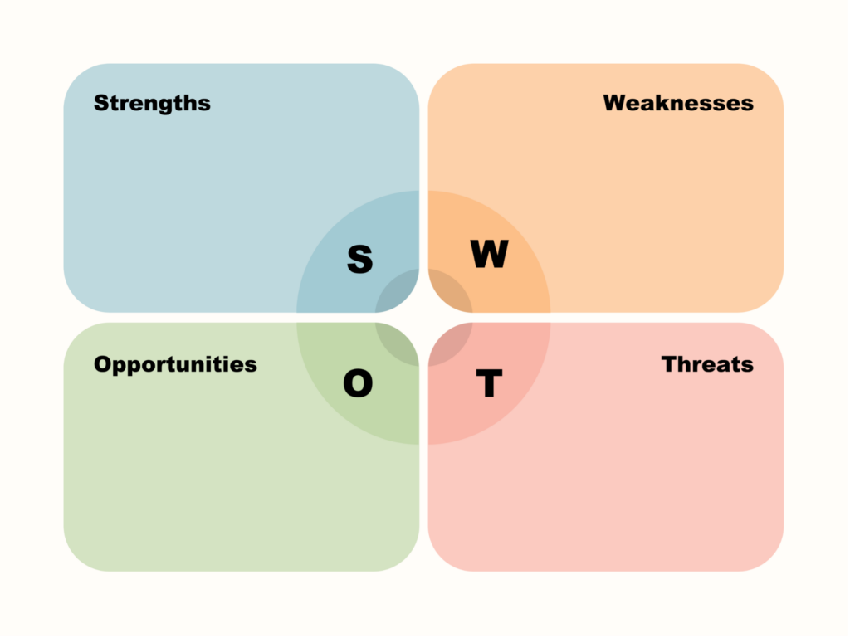

Fig no 4.1

SWOT analysis of Gilwood fashions

The textile industry is undergoing fast change as the industry continues to grow. Today’s enterprises have multiple benefits due to technological progress, resulting in everyday economic shifts. In order to effectively strategy. It is crucial for a textile organization to appreciate the patterns of market movement. An effective provides organizations with a head start in planning and a competitive advantage. SWOT analysis can be a reliable method for getting market research that can give your organization a competitive advantage. The strength, weakness, opportunities and threats of GFPL are as follows.

**1.Strengths:**

* Adaptation of new technology and machineries.
* Labor market flexibility.
* It has a wide distribution network.
* It’s very talented and skilled employees at all levels.
* Technology stable.
* Strong research and development team.
* Supportive government.
* Increasing industry involvement.
* Social easily acceptable GFPL products and support the industry/company.

**2. Weakness:**

* Political interference.
* Poor quality of standards.
* Inadequately developed linkages between R & D labs and industry.
* High requirement of working capital.
* Lower average consumption in domestic market.
* Low availability of new reliable instruments and equipment’s.

**3. Opportunities:**

* Production of garments made to measure.
* Consumers wish for new designs.
* Buyers can transparent costing facility.
* Easily availability of human resource.
* Training offered by governmental and non-governmental organizations.
* Growing demand for GFPL products.
* Greatly improved export potential for company products.
* Diversification into industrial products.

**4.Threats:**

* High competitions, high production costs and a low profit margin.
* The textile sector is gambling on monsoon.
* Substitute products.
* Government rules and regulations.
* Import of similar articles of clothing at low prices.

**CHAPTER-5**

**ANALYSIS OF FINANCIAL STATEMENTS**

BALANCE SHEET OF GILWOOD FASHIONS PVT.LTD (Rs in LAKS)

|  |  |  |  |
| --- | --- | --- | --- |
| **PARTICULARS** | **2021** | **2022** | **2023** |
| Sources of fund |  |  |  |
| Share holder’s fund |  |  |  |
| Share capital | 63 | 69.1 | 111.9 |
| Reserve and surplus | 528.96 | 787.32 | 1797.42 |
| Share application money |  | 333 |  |
| Advance money received | 12.63 |  | 20.27 |
| **TOTAL** | **604.59** | **1189.42** | **1929.58** |
| Loans funds |  |  |  |
| Secured loans | 666.73 | 1660.45 | 2146.72 |
| Unsecured loans | 47.63 | 55.04 | 333.42 |
| Deferred tax liabilities | 714.36 | 1715.48 | 2480.15 |
|  | **22.41** | **66.14** | **91.18** |
| **TOTAL** | **1341.36** | **2971.05** | **4500.91** |
| Application of fund |  |  |  |
| Fixed assets |  |  |  |
| Gross block | 469.95 | 956.5 | 2091.44 |
| Less: depreciation | 51.49 | 98.75 | 165.52 |
| Net block | 411.46 | 857.74 | 1925.92 |
| Capital work- in- progress | 267.81 | 715.28 | 554.26 |
| TOTAL | **679.27** | **1573.02** | **2480.18** |
| Investments | 58.08 | 332.28 | 439.48 |
| Current assets, loan & advances |  |  |  |
| Inventories  Sundry debtors | 321.7  201.84 | 475.14  310.72 | 695.58  177.25 |
| Cash and bank | 55.19 | 31.44 | 26.08 |
| Loans & advances | 130.84 | 154.37 | 240.58 |
| Advances to subsidiaries |  | 231.53 | 440,32 |
|  | **709.57** | **1203.2** | **1779.81** |
| Less;current liabilities and provisions |  |  |  |
| Current liabilities | 70.86 | 116.18 | 176.01 |
| Provisions | 34.69 | 21.3 | 22.52 |
|  | 105.55 | 137.47 | 198.53 |
| Net current assets | 604.02 | 1065.47 | 1581.25 |
| TOTAL | **1341.36** | **2971.05** | **4500.91** |
|  |  |  |  |

**INTERPRETATION**

The balance sheet shows that the assets and liabilities of the organization have increased from the previous years. The debt burden of the business has increase in both secured and unsecured loans. The capital blocked in work in progress has increased. The current assets of the company have increased from the previous year, due to increase in the cash balance and the increase in the debtors of the company, which shows the increased performance of the organization. But there is an increase in the current liabilities of the company also, which is due to the increase in the ongoing projects of the business.

**RATIO ANALYSIS**

1. **CURRENT RATIO**

Current ratio is one of the most fundamental liquidity ratio. It measures the ability of business to repay current liabilities with current assets, it also know as working capital ratio. A current ratio of one or more is preferred by investors. To calculate the ratio, analyst compare company’s current assets to its current liabilities.

**Current ratio = current assets/current liabilities**

**Table showing the level of current ratio of GFPL (**rupees in laks)

|  |  |  |  |
| --- | --- | --- | --- |
| YEARS | CURRENT ASSETS | CURRENT LIABILITIES | CURRENT RATIOS |
| 2020-2021 | 578.73 | 70.86 | 8.17 |
| 2021-2022 | 817.3 | 116.18 | 7.03 |
| 2022-2023 | 898.91 | 176.01 | 5.11 |

**ANALYSIS**

According to the above table during the year 2023 current ratio is more than 5.11 in the year 2022 current ratio is 7.03, in the year 2021 current ratio is 8.17

**INTERPRETATION**

The above table revals that company current ratio is increasing from 2021which depicts company’s ability to pay back is current liabilities efficiently with is current assets. If the ratio is less than one the company then the company have problems while paying back is liabilities.

**2.NET WORKING CAPITAL**

net working capital is the aggregate of all current assets and current liabilities it is used to measure the short-term liquidity of business.

**Net working capital= current assets – current liabilities**

**Table showing the level of net working capital of GFPL (**Rupees in laks)

|  |  |  |  |
| --- | --- | --- | --- |
| **YEARS** | **CURRENT ASSETS** | **CURRENT LIABILITIES** | **NET WORKING CAPITAL** |
| 2021 | 578.73 | 70.86 | 507.84 |
| 2022 | 817.3 | 116.18 | 701.12 |
| 2023 | 898.91 | 176.01 | 722.9 |